Temperamental Experience

Each advance is associated with a temperament (see below). Characters with advances spread evenly across the four temperaments have balanced humors. Characters with advances concentrated on one temperament possess an imbalance of humors.
Temperament | Choleric | Melancholic | Phlegmatic | Sanguine | Humor | Disposition | Element | Organ | Season
Choleric | Same | Similar | Opposite | Similar | Yellow Bile | Hot, Dry | Fire | Liver | Fire
Melancholic | Similar | Same | Similar | Opposite | Black Bile | Cold, Dry | Earth | Spleen | Autumn
Phlegmatic | Opposite | Similar | Same | Similar | Phlegm | Cold, Wet | Water | Brain | Winter
Sanguine | Similar | Opposite | Similar | Same | Blood | Hot, Wet | Air | Heart | Spring

Total up the temperament of each of your character’s advances. (The free Common Knowledge and Speak Language do not count.)
If a character has 5 more advances of one temperament than any other temperament, his humors are out of balance and he is subject to that temperament until either A) additional advances are purchased that reduce the gap to less than 5 or B) the number of advances of a different temperament exceeds any other temperament by 5 or more and exceeds the number of advances of the previous temperament.
For example: Aladár Árpád has 7 Choleric advances, 7 Melancholic Advances, 4 Phlegmatic advances, and 3 Sanguine advances.
- Aladár buys a WS (Choleric) advance. He now has 8 Choleric advances, which is 5 more than he has Sanguine advances. He is now Choleric.
- Aladár buys an Int (Melancholic) advance. He now has 8 Melancholic advances, which is 5 more than he has Sanguine advances… but he’s already Choleric, and his Melancholic advances do not outnumber his Choleric advances.
- Aladár buys another Int (Melancholic) advance. He now has 9 Melancholic advances, which is both 5 more than he has Sanguine advances and more than he has Choleric advances. He is now Melancholic.
- Aladár buys two Ag (Sanguine) advances. He now has 9 Melancholic advances and 5 Sanguine advances; the difference is no longer 5 or more, so he is no longer Melancholic (or Choleric) and has balanced humors.
Advance Temperament  Balanced Same Similar Opposite  CHARACTERISTICS Simple (+5%) 150 100 250 500  Intermediate (+10%) 300 200 500 750  Trained (+15%) 550 350 750 1,000  Proficient (+20%) 800 600 1,000 1,500  Expert (+25%) 1,050 850 1,500 2,500  SKILLS Known (+0%) 150 100 200 250  Trained (+10%) 300 200 400 500  Experienced (+20%) 450 300 600 750  Veteran (+30%) 600 400 800 1,000  TALENTS Tier 1 300 200 400 600  Tier 2 450 300 600 900  Tier 3 600 400 900 1,200 | 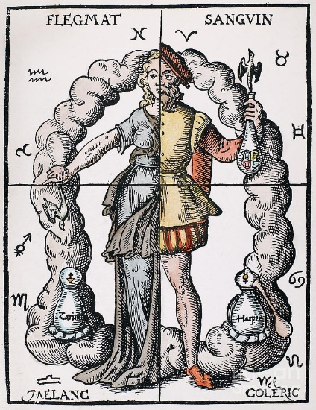
Balanced humors mean that all advances cost the same amount of XP. Imbalanced humors make the advances associated with a characters temperament significantly cheaper, but advances associated with other temperaments are more expensive. Advances listed as ‘None’ (and there are a few) always cost the Balanced amount.
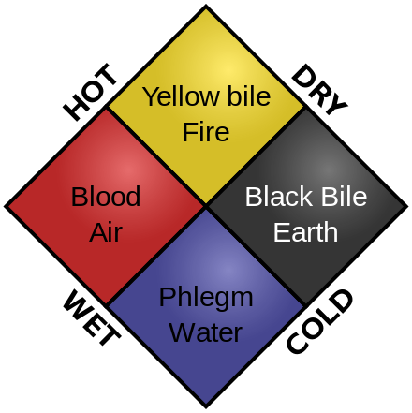 | Characteristic Temperament  WS Choleric  BS Phlegmatic  S Choleric  T Phlegmatic  Ag Sanguine  Int Melancholic  WP Melancholic  Fel Sanguine

Skill | Temperament | Skill | Temperament | Skill | Temperament
Animal Care | Melancholic | Row | Choleric | Magical Sense | Melancholic
Charm | Sanguine | Scale Sheer Surface | Choleric | Navigation | Phlegmatic
Command | Choleric | Search | Melancholic | Performer (*) | Sanguine
Concealment | Phlegmatic | Silent Move | Sanguine | Pick Lock | Melancholic
Consume Alcohol | Phlegmatic | Swim | Choleric | Prepare Poison | Melancholic
Disguise | Sanguine | Animal Training | Sanguine | Read/Write | Melancholic
Drive | Choleric | Blather | Sanguine | Sail | Phlegmatic
Evaluate | Melancholic | Chanelling | Melancholic | Set Trap | Melancholic
Gamble | Melancholic | Charm Animal | Sanguine | Secret Signs (*) | Melancholic
Gossip | Sanguine | Dodge Blow | Phlegmatic | Shadowing | Sanguine
Haggle | Sanguine | Follow Trail | Melancholic | Sleight of Hand | Sanguine
Intimidate | Choleric | Heal | Melancholic | Speak Language (*) | Melancholic
Outdoor Survival | Phlegmatic | Hypnotism | Melancholic | Trade (*) | None
Perception | Melancholic | Knowledge (*) | Melancholic | Torture | Choleric
Ride | Sanguine | Lip Reading | Melancholic | Ventriloquism | Sanguine

Talent | Temperament | Tier | Talent | Temperament | Tier
Acute Hearing | Melancholic | 1 | Fearless | Phlegmatic | 1
Aethyric Attunement | Melancholic | 1 | Flee! | Phlegmatic | 1
Alley Cat | Sanguine | 1 | Fleet Footed | Sanguine | 1
Ambidextrous | Choleric | 1 | Frenzy | Choleric | 1
Armoured Casting | Phlegmatic | 1 | Hardy | Phlegmatic | 1
Artistic | Sanguine | 1 | Keen Senses | Melancholic | 1
Belligerent | Choleric | 2 | Lightning Parry | Choleric | 1
Contortionist | Sanguine | 1 | Lightning Reflexes | Sanguine | 1
Coolheaded | Melancholic | 1 | Linguistics | Melancholic | 1
Dealmaker | Choleric | 1 | Lore (*) | Melancholic | 1
Disarm | Choleric | 1 | Luck | None | 3
Etiquette | Sanguine | 1 | Magic | Melancholic | 1
Excellent Vision | Melancholic | 1 | Marksman | Phlegmatic | 1
Fast Hands | Choleric | 1 | Master Gunner | Phlegmatic | 1

Talent | Temperament | Tier | Talent | Temperament | Tier
Master Orator | Choleric | 1 | Stout-Hearted | Phlegmatic | 1
Meditation | Phlegmatic | 1 | Street Fighting | Choleric | 1
Menacing | Choleric | 1 | Streetwise | Sanguine | 1
Mighty Shot | Phlegmatic | 1 | Strike Mighty Blow | Choleric | 1
Mimic | Sanguine | 1 | Strike to Injure | Choleric | 1
Orientation | Phlegmatic | 1 | Strike to Stun | Choleric | 1
Public Speaking | Choleric | 1 | Strong-Minded | Melancholic | 1
Quick Draw | Sanguine | 1 | Sturdy | Phlegmatic | 1
Rapid Reload | Sanguine | 1 | Suave | Sanguine | 1
Resist Chaos | Phlegmatic | 1 | Sure Shot | Phlegmatic | 1
Resist Disease | Phlegmatic | 1 | Surgery | Phlegmatic | 1
Resist Magic | Phlegmatic | 1 | Super Numerate | Melancholic | 1
Resist Poison | Phlegmatic | 1 | Swashbuckler | Sanguine | 1
Rover | Phlegmatic | 1 | Trapfinder | Sanguine | 1
Savvy | Melancholic | 1 | Trick Riding | Sanguine | 1
Schemer | Sanguine | 1 | Tunnel Rat | Sanguine | 1
Seasoned Traveller | Melancholic | 1 | Very Resilient | Phlegmatic | 1
Sharpshooter | Phlegmatic | 1 | Very Strong | Choleric | 1
Sixth Sense | Melancholic | 1 | Warrior-Born | Choleric | 1
Specialist Weapon Group | Choleric | 1 | Wrestling | Choleric | 1

Talent Changes
- Belligerent is a new Talent that confers +1 Attack. It may be taken more than once: up to a number of times equal to half the character’s WS bonus (rounded down).
- Fleet Footed may be taken more than once: up to a number of times equal to half the character’s Ag bonus (rounded down).
- Hardy may be taken more than once: up to a number of times equal to the character’s Toughness bonus.

